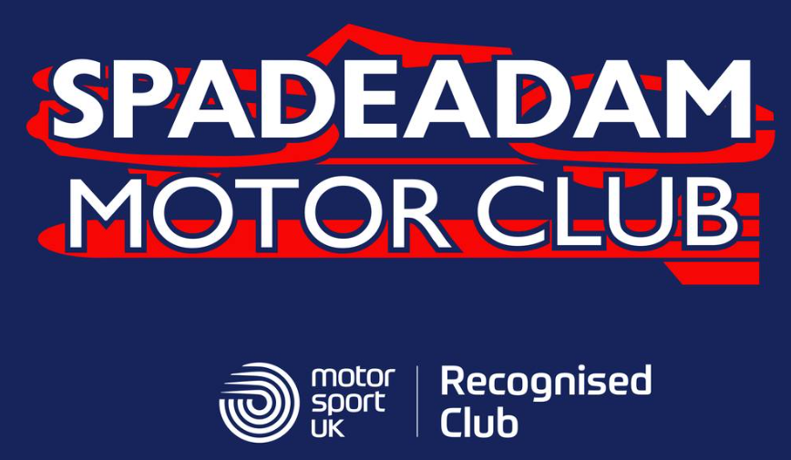

We are looking for assistance to see if you can bring a team of marshals to Spadeadam Motor Clubs Blue Streak Targa event on 28th June 2026. The event starting at Plenmeller, Haltwhistle and finishing at J45 Truckstop Gretna.

We would need marshals to sign on before 0800 on the morning and be in position before the first car sets off at 0900. There will be the usual goodie bag and pasty for all marshals. There is also going to be a hot food van at the start where people can buy breakfast rolls. Jn45 Truckstop will have their cafe open for lunch and tea if people want extra food.

We need as many marshals as possible for the morning and afternoon.

We will be using the Sapphire rally timing app again this year so if you have a few people that are use to the app then please encourage them to come. We will be supplying battery phone packs for the day to ensure peoples phones stay charged. WE also need anyone that wants to come and cone watch or help on the day.

The following link provides advice on how to use the app. It will be beneficial if marshals have the latest version downloaded to their phones before they attend the event, that way they can download it have a play with the app before the event.

App Guide

I will supply more details in the next few weeks.

If you could indicate how may marshals you could bring and a lead contact that would assist me in planning the marshal allocation.

Regards
David Garstang
07824 352172

